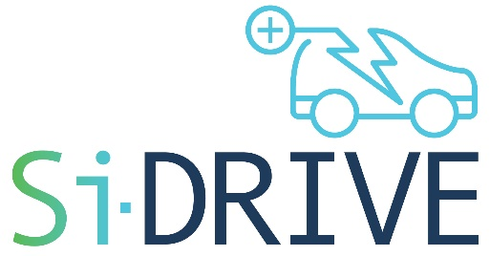
Silicon Alloying Anodes for High Energy Density Batteries comprising Lithium Rich Cathodes and Safe
Ionic Liquid based Electrolytes for Enhanced High VoltagE Performance

Grant Agreement Number 814464

2nd Project Meeting, September 26-27, 2019, Rome (Italy)
Draft Agenda
Organizers: ENEA, CNR

Consortium
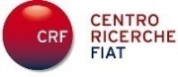

Thursday, September 26, 2019
Location: ENEA HQ
Lungotevere Thaon Di Revel 76, 00196 Rome

8:45 | 15’ | Arrivals & Welcome | ENEA
9:00 | 10’ | Opening remarks | ENEA
9:10 | 30’ | Introduction and General Comments/Notes by the Coordinator | UL
9:40 | 50’ | WP1 Activities – Anode development  - Overview by WP leader (10’), including advance towards deliverables and milestones  - Work carried out by active partners (10’ each) | UL (Leader)  MBNL, CIDETEC, KIT
10:30 | 15´ | Coffee Break
10:45 | 60’ | WP2 Activities – Electrolyte development  - Overview by WP leader (10), including advance towards deliverables and milestones  Work carried out by active partners (10’ each) | ENEA (Leader)  CNR, POLITO, SOLVIONIC, CRF
11:45 | 30’ | WP3 Activities – Cathode development  - Overview by WP leader (10’), including advance towards deliverables and milestones  - Work carried out by active partners (10’ each) | KIT (Leader)  ZSW
12:15 | 10’ | WP4 Activities – Full cell testing  - Overview by WP leader (10’), including advance towards deliverables and milestones  - Work carried out by active partners (if done) | CIDETEC (Leader)  ENEA, KIT, ZSW, UL, LITHPOS, CRF
12:25 | 50’ | WP5 Activities – Component Modelling  - Overview by WP leader (10’), including advance towards deliverables and milestones  Work carried out by active partners (10’ each) | DLR (Leader)  CNR, GEM, UL
13:15 | 90´ | Lunch
14:45 | 10’ | WP6 Activities – Prototype Testing/Validation  - Overview by WP leader (10’), including advance towards deliverables and milestones  - Work carried out by active partners (if done) | LITHOPS (Leader)  CIDETEC, CRF, RWTH, ZSW
14:55 | 50’ | WP7 Activities – LCA and 2nd Life Assessment  - Overview by WP leader (10’), including advance towards deliverables and milestones  - Work carried out by active) partner (5-10’ each) | KUL (Leader)  EMPA, RWTH, CIDETEC, GEM, UL, LITHOPS, CRF
15:45 | 15´ | Coffee Break
16:00 | 60’ | Discussions on WP1-WP7 activities | All
17:00 |  | Conclusion of the 1st meeting day
19:30 |  | Dinner (to be defined) | ENEA

Friday, September 27, 2019
Location: CNR
Piazzale Aldo Moro 7, 00185 Rome

9:45 | 15’ | Arrivals & Welcome | CNR
10:00 | 10’ | Opening remarks | CNR
10:10 | 30’ | WP8 Activities – Dissemination, Exploitation and Communication  - Overview by WP leader, including advance towards deliverables and milestones  - Work carried out by active partners (if done) | UL (Leader)  All
10:40 | 30’ | WP9 Activities – Project Management  - Management and reporting – Amendments  - Scientific Coordination  - General overview of the project at M9 | UL (Leader)  All
11:10 | 15´ | Coffee Break
11:25 | 60’ | General discussion on Work-plan  - Discussion on technical aspects of activities during the semester; pending issues  - Overview of tasks, deliverables and milestones; future planning  - Next meeting | All
12:25 | 20’ | Conclusions & Closing Remarks | UL
12:45 | 90’ | Lunch (Departure) | CNR

